How much gas is used when you idle?
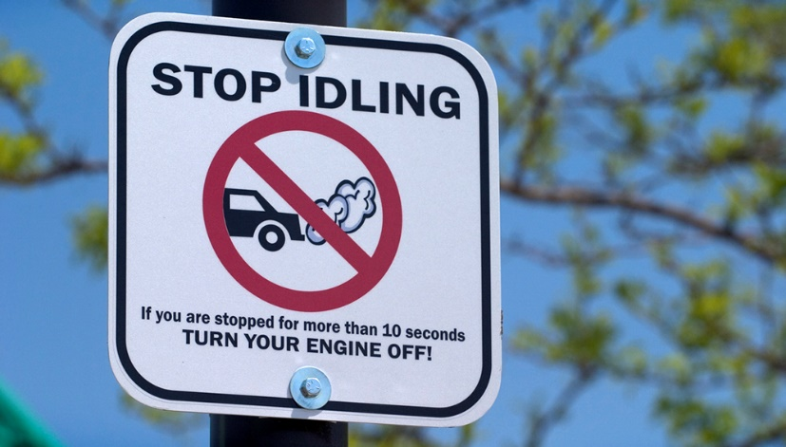

How to calculate how much gasoline is used by an idling vehicle:
Different sized engines consume gas at different rates when they are idling.
Vehicle Type (Engine Size in Liters) | Idling Fuel Use (with no car accessories, like AC or radio, running)
Light-duty gasoline-fueled vehicles (passenger vehicles) | 0.0053 gal/min (or 0.32 gal/hr)
Light-duty gasoline-fueled trucks (pick-up trucks, SUVs, minivans) | 0.0118 gal/min (or 0.71 gal/hr)
To calculate how much gasoline is used by an idling vehicle: (total minutes idling) x (gal/min) = Gallons of Gas

Example: Calculate the total amount of gas consumed while idling by a woman driving a sedan for one week.
Typical daily schedule:
- 7am: While driving her child to school, she picks up another student at their house. She idles for 9 minutes outside their house.
- 7:15am: While waiting in the drop-off line at school, she idles for 12 minutes.
- 12pm: She leaves work to grab some lunch. She leaves her car running for 8 minutes while she runs into a convenience store.
- 3:30pm: While waiting in the pick-up line at school, she idles for 14 minutes.

